**GIT**

**GITHUB:** https://github.com/SanthiyaaV/learning-program-solutions

**Task1 :GitLab config using Gitbash**

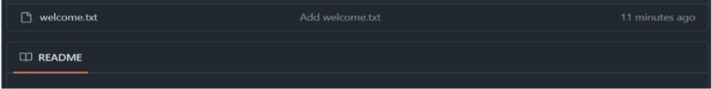

**Task2 : Create a “.log” file and a log folder in the working directory of Git**

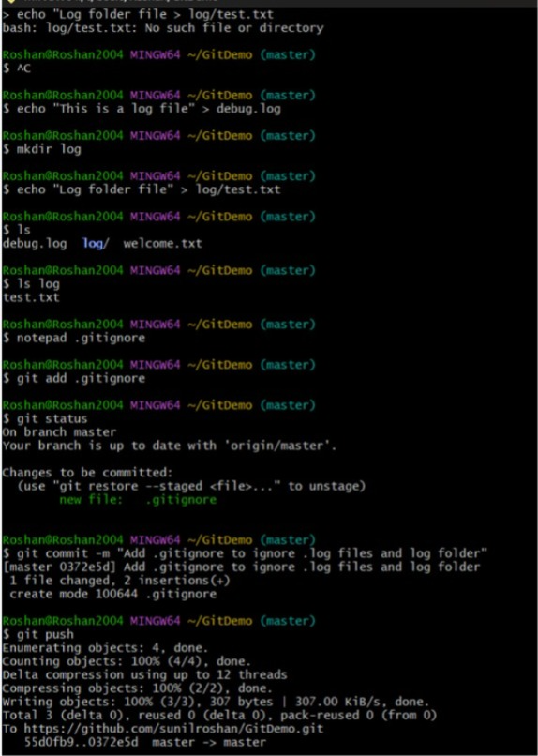

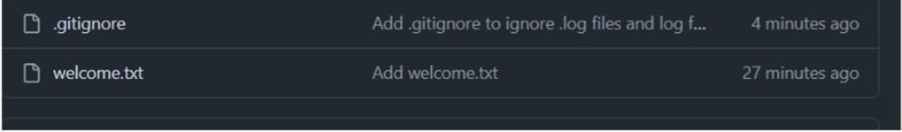

**Task 3 : Git Branching and Merging**

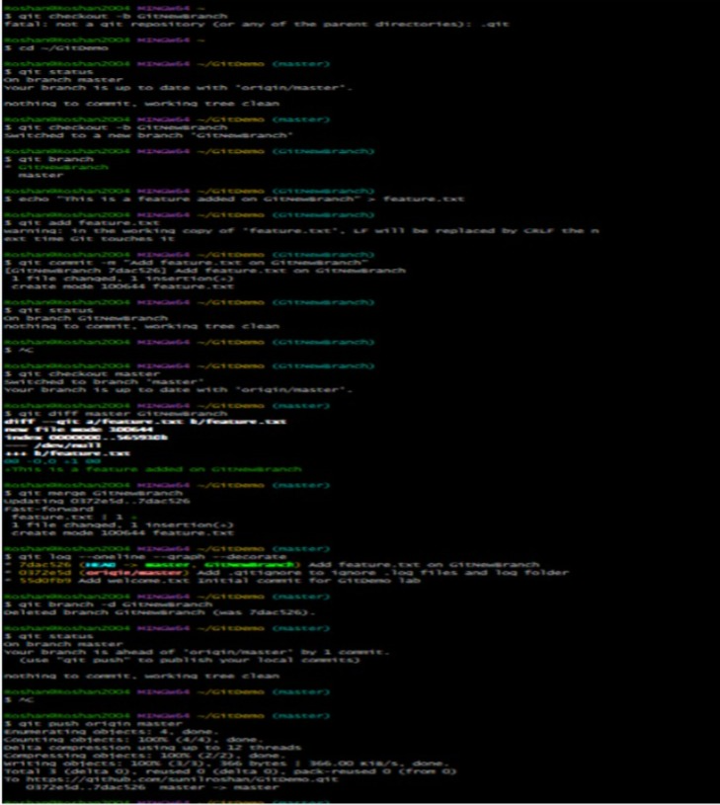

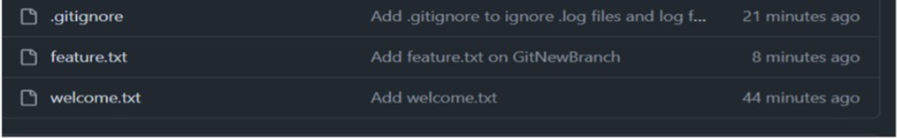

**Task 4 : Implement conflict resolution when multiple users are updating trunk**

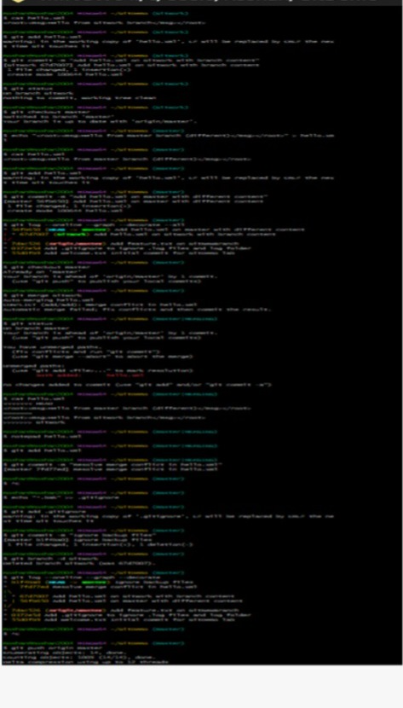

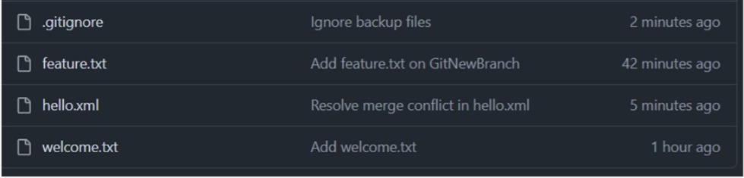

**Task5 : Execute steps involving clean up and push back to remote Git**

